 ­

Abdullah Gül University

Department of Computer Engineering

Embedded Systems

Smart Watch Project Progress Report

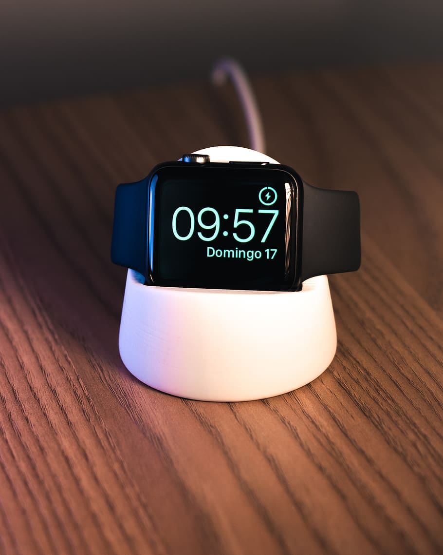

Instructor

Abdulkadir Gülşen

09.05.2025

Introduction

This report aims to provide a comprehensive view of the objectives and the ongoing development process of the Smart Watch Project. Main goal of this project is to design and develop a wearable device that will integrate multiple functions into a simulation environment. Specifically, it is intented to monitor and display key health conditions such as hearth pulse rate, keep track of time and assessing various environmental conditions such as temperature. Recently wearable devices has gained important attention because of its assisting potention in managing well-being of people in real time. The Smart Watch Project builds on this regard by incorporating essential sensors capabilities to provide its owners timely and necessary informations on their wrists. The project aims to deliver accurate data visualization without losing all in one utilization. This report will detail the key stages of the project development process, including design considerations for simulation, component selection. It will also highlight the progress made so far, challenges encountered and planned future steps to ensure successful project completion.

1- Design

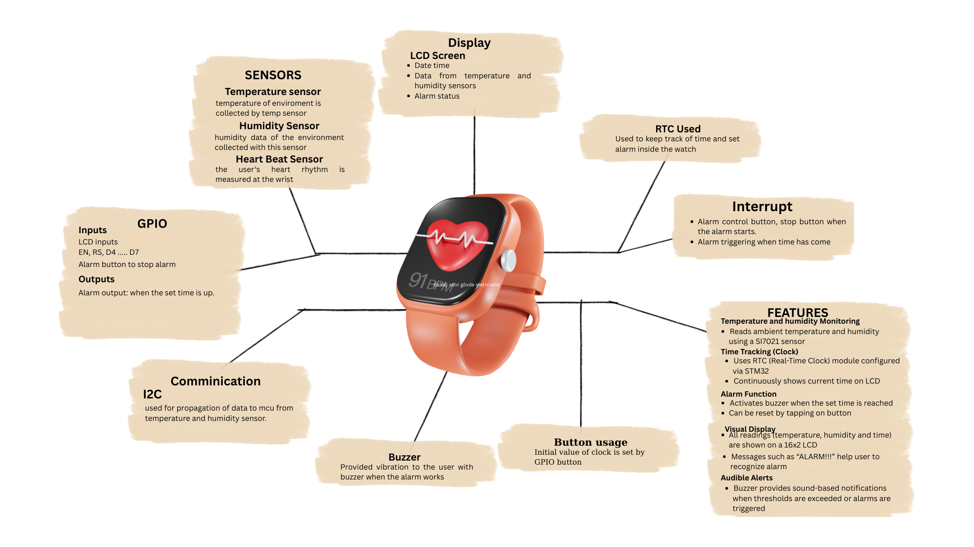Features:

The Smart Watch Project combines multiple features to monitor both health and environmental conditions in real time. By measuring temperature and humidity using SI7021 sensor in simulation environment and displaying the values on 16x2 LM016L LCD and triggering a buzzer when the values exceed the defined threshold values it aims to make life easier for its users. Heart rate is monitored through pulse sensor, with BPM values displayed and alerts if rates fall outside of the normal range. A real time clock (RTC) provides continous time tracking, and an alarm that is implemented on watch notifies user via buzzer when the time set is reached. The system is fully simulated using proteus, with the microcontroller configured via STM32CubeMX and programmed in Keil MDK.

Implementation